How to Join a class on Google Classroom
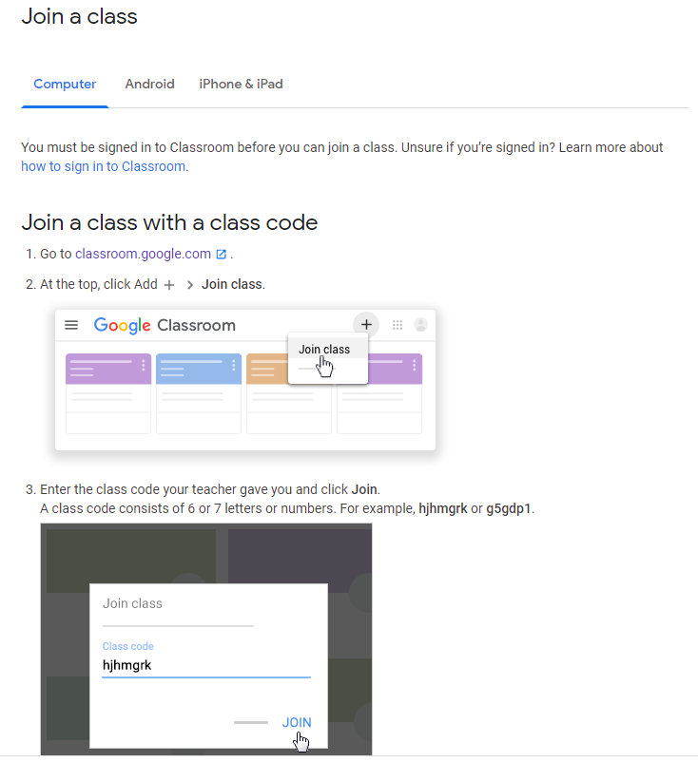
Class Code:
